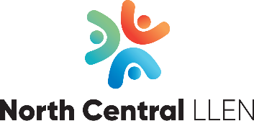

NOMINATION FORM Board of Management June 2022 – May 2024

Nominated By
I ………………….…………………….. (name), nominate (name)
to become a member of the North Central LLEN Inc. Board of Management

…………………………….………………. (signature)

Seconded by
I …………………………………………….. (name), second the nomination of……. (name)
to become a member of the North Central LLEN Inc. Board of Management

………………………………….…………. (signature)

Nomination Accepted By
I …………………. (name) accept this nomination

…….……….…………………………………. (signature), ………………………………………(date)

The nominated person is to provide the following information (which will be sent out with voting forms if an election is required):

Address:
Occupation:
Phone Number(s):
Email Address:

List any skills relevant to a position on the Board:

Reasons for nominating (max. 150 words – this will be used on ballot papers):
Nominations are due by Friday 29 April 2022. Please email signed nomination form to officemanager@ncllen.org.au (scanned) or post to PO Box 12, Charlton VIC 3525

